# AP Art and Design Syllabus Mrs. Turner [Tanya.Turner@Cobbk12.org](mailto:Tanya.Turner@Cobbk12.org) Room 810

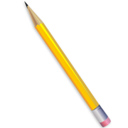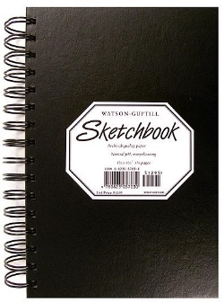  
**AP Art and Design**The AP studio art portfolio courses are designed for students who are seriously interested in the practical experience of art and wish to develop mastery in the concept, composition, and execution of their ideas. AP studio art is not based on a written exam; instead students submit portfolios for evaluation at the end of the school year. Students are expected to perform to levels of expectation that would be concurrent with a typical freshman level college course.

**Grading Weights**

**Art Production 40%**

Completed works

**Presenting and Responding 20%**

Critique and written reflection

**Research and Process 20%**Sketchbook documentation

**Connecting 10%**

Time management, professionalism, studio maintenance

**Final Exam 10%**

## Required Supplies

1. **Sketchbook**
2. **Pens and pencils**
3. **Erasers**
4. **Paint brushes**

**Optional Supplies**

Students who choose to explore non-traditional materials not available in the classroom are responsible for sourcing their own supplies.

**Policies**

1. **Cell Phones:**   
   Should **not** be seen unless given permission to use for instructional purposes.
2. **Food & Drink**:   
   Not permitted.
3. **Water Bottles:**Store under desks at all times.
4. **Restroom:**   
   Requires a hall pass from the teacher.
5. **Materials:**   
   Must be cared for properly. Alternate assignments will be provided if supplies are misused.
6. **Dismissal:**   
   Takes place only after proper clean-up procedures are met

**Expectations**

1. **Arrive on time.**
2. **Show up prepared.**
3. **Start work immediately.**
4. **Control volume.**
5. **Care for the studio**
6. **Respect each other.**

