# 

# Applied Design Syllabus Mrs. Turner [Tanya.Turner@Cobbk12.org](mailto:Tanya.Turner@Cobbk12.org) Room 810

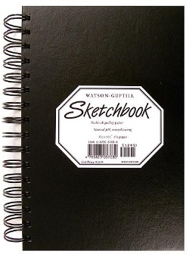

**Applied Design** develops advanced 2-dimensional art skills. Students focus on practicing contemporary studio habits, working much in the same way as professionals in the art industry. Ideas and processes are developed on an individual basis, providing the foundation for an AP-ready portfolio. Applied Design is considered a pre-requisite for AP Studio Art students.



**In-Person Expectations**

* **Cell Phones Put Away**
* **No Food or Drink**
* **Water Bottles Stored Under Desk**
* **Use Pass for Restroom**
* **Care for Materials**
* **Be Respectful of Peers**
* **Late Work -10 Points Per Day**
* **Plagiarized Work Receives a Zero**

**Grading Weights**

**Art Production 40%**

**Creative Process 30%**

**Art History 20%**

**Final Exam 10%**

**Supplies**



<https://tinyurl.com/yxebkam3> ​

**Online Expectations**

* **Arrive on Time**
* **Stay for Duration of Class**
* **Be an Active Participant**
* **Use School Appropriate Filters/Backgrounds**
* **Late Work -10 Points Per Day**
* **Plagiarized Work will Receive a Zero**
* **Abide by Student Code of Conduct**

**Contact**

[Tanya.Turner@cobbk12.org](mailto:Tanya.Turner@cobbk12.org)