# Visual Art Comprehensive Syllabus Mrs. Turner [Tanya.Turner@Cobbk12.org](mailto:Tanya.Turner@Cobbk12.org) Room 810

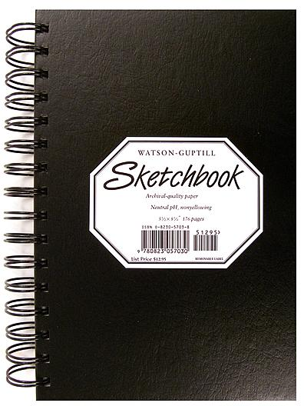  
**VA Comprehensive** Introduces art history, art criticism, aesthetic judgment, and studio production. The course emphasizes the ability to understand and use elements and principles of design through a variety of media, processes, and visual resources. We explore master artworks for historical and cultural significance.

**Grading Weights**

**Art Production 40%**

**Creative Process 30%**

**Art History 20%**

**Final Exam 10%**

## Required Supplies

**See reverse for a list of all required supplies.**

**Art kits will be available for purchase, which includes all required supplies at a discounted rate.**

**Expectations**

1. **Arrive on time.**
2. **Show up prepared.**
3. **Start work immediately.**
4. **Control volume.**
5. **Care for the studio**
6. **Respect each other.**

**Policies**

1. **Cell Phones:** Should **not** be seen unless given permission to use for instructional purposes.
2. **Food & Drink**: Not permitted. Do you like ants? …because that is how you get ants!
3. **Water Bottles:** Keep away from artwork in case of spills
4. **Restroom:** Requires a pass from the teacher.
5. **Materials:** Must be cared for properly. Alternate assignments will be provided if supplies are misused.
6. **Dismissal:** Takes place only after proper clean-up procedures are met
7. **Differentiation:** Is used to keep ALL students on track with content standards.
8. **WE FOLLOW ALL HHS AND COBB COUNTY RULES IN THIS CLASSROOM**

