# 

# Drawing 1 Syllabus Mrs. Turner [Tanya.Turner@Cobbk12.org](mailto:Tanya.Turner@Cobbk12.org) Room 810

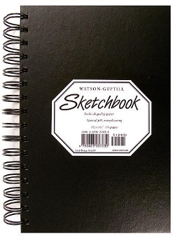

**Drawing 1** Explores a variety of drawing techniques and media; emphasizes developing basic drawing skills and critical analysis skills for responding to master drawings. Examines solutions to drawing problems through student drawings and those of other artists. Covers Western and non-Western cultures.



**In-Person Expectations**

* **Cell Phones Put Away**
* **No Food or Drink**
* **Water Bottles Stored Under Desk**
* **Use Pass for Restroom**
* **Care for Materials**
* **Be Respectful of Peers**
* **Late Work -10 Points Per Day**
* **Plagiarized Work Receives a Zero**

**Grading Weights**

**Art Production 40%**

**Creative Process 30%**

**Art History 20%**

**Final Exam 10%**

**Supplies**



<https://tinyurl.com/y4et7n3x>

**Online Expectations**

* **Arrive on Time**
* **Stay for Duration of Class**
* **Be an Active Participant**
* **Use School Appropriate Filters/Backgrounds**
* **Late Work -10 Points Per Day**
* **Plagiarized Work will Receive a Zero**
* **Abide by Student Code of Conduct**

**Contact**

[Tanya.Turner@cobbk12.org](mailto:Tanya.Turner@cobbk12.org)