# 

# Visual Art Comprehensive Syllabus Mrs. Turner [Tanya.Turner@Cobbk12.org](mailto:Tanya.Turner@Cobbk12.org) Room 810

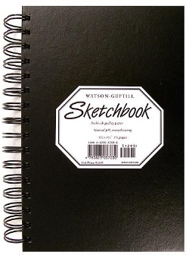

**VA Comprehensive** Introduces art history, art criticism, aesthetic judgment, and studio production. The course emphasizes the ability to understand and use elements and principles of design through a variety of media, processes, and visual resources. We explore master artworks for historical and cultural significance.



**In-Person Expectations**

* **Cell Phones Put Away**
* **No Food or Drink**
* **Water Bottles Stored Under Desk**
* **Use Pass for Restroom**
* **Care for Materials**
* **Be Respectful of Peers**
* **Late Work -10 Points Per Day**
* **Plagiarized Work Receives a Zero**

**Grading Weights**

**Art Production 40%**

**Creative Process 30%**

**Art History 20%**

**Final Exam 10%**

**Supplies**

**Online Expectations**

* **Arrive on Time**
* **Stay for Duration of Class**
* **Be an Active Participant**
* **Use School Appropriate Filters/Backgrounds**
* **Late Work -10 Points Per Day**
* **Plagiarized Work will Receive a Zero**
* **Abide by Student Code of Conduct**

**Contact**

Tanya.Turner@cobbk12.org